How to evaluate a web site: The 7 Cs framework

Context | The context of the website captures its aesthetic and functional look-and-feel. Some sites have chosen to focus heavily on interesting graphics, colors and design features, while others have emphasized more simpler utilitarian goals, such as ease of navigation..
Example:
The following is a webpage from landsend.com. The balance of both aesthetic(pastel colors, simple warm visuals) and functional (crisp, uncluttered) design elements to communicate its core benefits—traditionally designed clothing, great service and moderate prices.

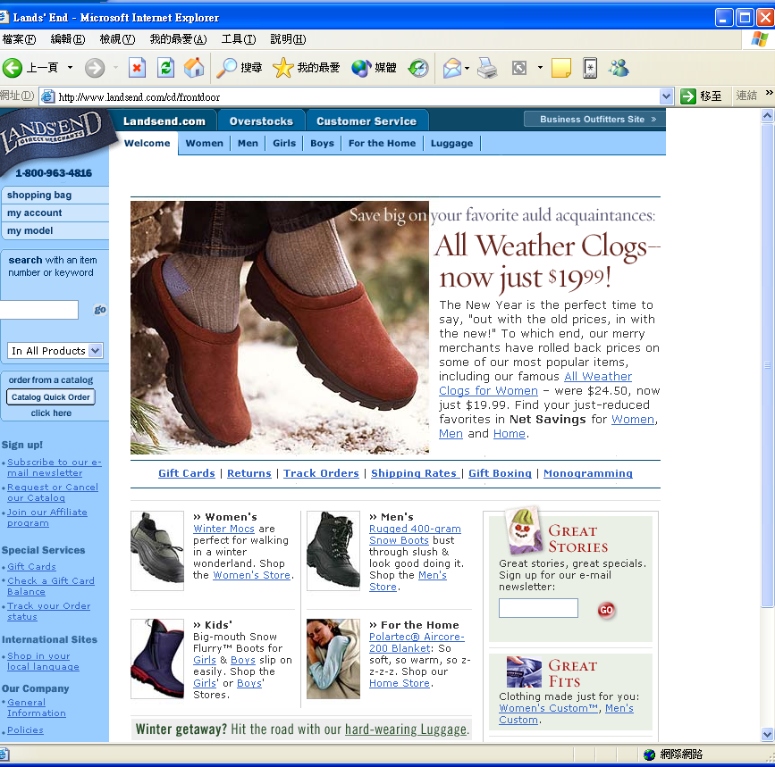

The following is a page from luckybrandjeans.com. In sharp contrast, this com is a more hip, nontraditional brand. Its website is comparatively more edgy, with bolder colors, humor (the get lucky slogan) and a more focused product line.
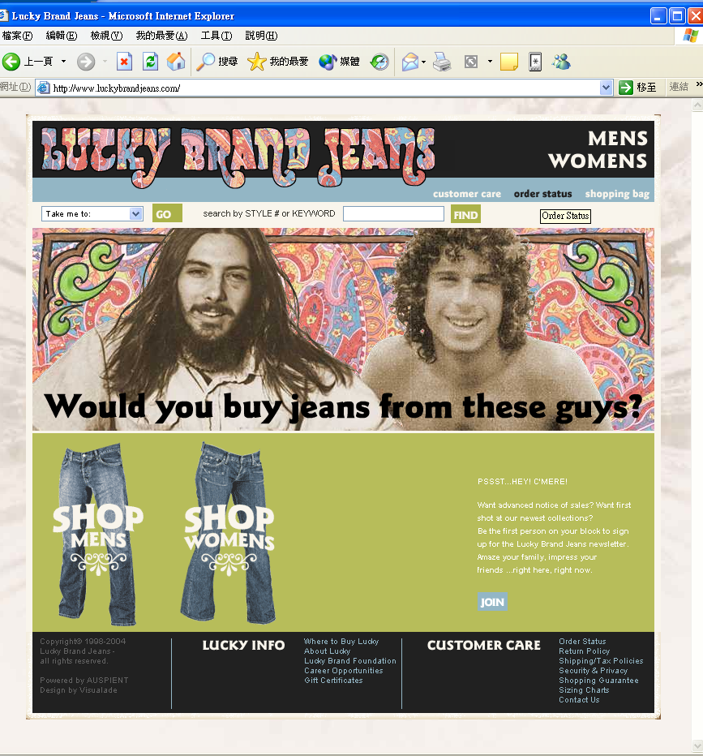

Landsend.com customers might not find the luckyjeans.com appealing, purely because of its look and feel. Luckybrandjeans.com suggests a younger, more urban, and fashion-forward target segment.

Content | Content is defined as all digital subject matter on the site. This includes the from of the digital subject matter—text, video, audio and graphics— as well as the domains of the digital subject matter, including product, service, and information offerings. While context largely focuses on the “how” of site design, content focuses on “what” is presented.
Example:
Landsend.com includes content pertaining to its product offerings, services, and offline support. In terms of media, the site uses a combination of text, photos and graphics to convey its content.

Community | Community is defined as the interaction that occurs between site users. It does not refer to site-to-user interactions. User-to-user communication can occur between two users (e-mails, online games) or between one user and many (eg chat rooms)
Example:
Landsend.com has an innovative community feature that allows two users to shop simultaneously on its site. This trademarked service termed “Shop with a Friend” enables two users to view the site at the same time, browse together, and purchase the product. It is a virtual shopping experience.

Customization | Customization is defined as the site’s ability to tailor itself or to be tailored by each user. When the customization is initiated and managed by the firm, we term it tailoring. When the customization imitated and managed by the user, we term it personalization.
Example:
On Landsend,com, the user is able to personalize the site to limited degree, using a feature called the personal shopping account. Here, the user can enter basic personal information, complete an address book for potential recipients of purchases, and enter key dates in the reminder service. In turn, once personal profile data is entered and consumers begin to use the site, the site uses this data to tailor email messages, banner ads, and the content of the site to the individual.

Communication | Communication refers to the dialogue that unfolds between the site and its users. This communication can take three forms: site-to-user communication (eg email notification), user-to-site (eg customer service request), or two-way communication (eg instant messaging)
Example:
Landsend.com has introduced a communication feature called “Lands’ End Live” which enables the user to talk directly with the customer service representative while shopping on the site. Clicking the Land’s End Live button results in two options:
(1) connection by phone (this assumes the user has two phone lines), a direct Internet connection by DSL, or by cable modem or
(2) connection by live text chat

Connection | Communication is defined as the extension of the formal linkages between the site and other sites.
Example:
Landsends.com does not have any connections to other sites; however, it does have an affiliates program that allows other sites to connect to Lands’End. In particular, Landsend.com supplies the affiliate site with banner ads to link visitors from the site to the Landsend.com store. The affiliate partner earns 5 % on every sale that occurs on a click-through from the site. If a customer is a first-time Lands’ End buyer, the affiliate earns an additional finder’s fee

Commerce | Commerce is defined as the sale of goods, products, or services on the site.
Example:
The Landsend.com site obviously has transactional capability. It has the typical “shopping basket” feature along with shipping (ie to home, to someone else’s home, or to the office) information. The shopping basket can be viewed as any point in the shopping experience. It includes such information as quantity, description, size, prices and availability, and it also provides options to “delete the item” and “order more of this”

Finally, the following is a check list that may be helpful for the evaluation of a website. You may use it as a guideline.
A check list on the evaluation of a website:

 | Yes | No
Impression on first entry
The URL/Domain Name is appropriate and meaningful
The surfer sees something meaningful within 8 seconds
The Site Name and Product/Purpose come up instantly
Text is visible (and held steady) while graphics are loaded
The Homepage is exciting, interesting, attention-grabbing
There is useful information on the Homepage
The Homepage looks good, and has a clean, uncluttered look
Important information is 'above the fold' (top 600 x 300)
Not distracted by excessive animation or flash
The Homepage contains the key facts
Name of Organization (preferably in H1 text heading)
Shows business, products, where based
Style appropriate for target audience
Shows the sort of information available in the site
Shows name, address, telephone, fax, Email
TITLE is meaningful
Shopping Experience
Friendly and quick route to buy
Secure handling of credit card information
Order acknowledged with delivery date stated
Order tracking provided
Delivery reliable
Returns policy stated
Certificates obtained from trade bodies
Privacy of Data statement
Appropriate use of cookies
Back Office Support
Email response address on every page
What to do about faults, comments, suggestions, feedback
Same day acknowledgement of all Emails
Timely and full answer to Emails

 | Yes | No
Links are clear and meaningful
Not more than 7 options in any menu
Image-links are appropriate and consistent
Image-links have ALT words and supported by text-links
The whole site has a structure
It is clear what the structure of the site is
Useful content is not more than three clicks from the homepage
There is a List of Contents or a Site-Map with links to every page
Each web-page has links back to the Contents or Site-Map
There are appropriate links on to other useful pages
Search tool is provided if appropriate
All the pages obey the same rules
Each web-page has a proper title
The title shows why users should look at this page
Titles are consistent with the words used to link to it
Text is shown in centered tables (say 550 pixels wide)
Long web-pages have their own structure
Long web-pages are used when it is useful to print as a whole
Avoid long tables, use several short ones
Users are warned if access time is likely to be long
Each displayed part of the web-page has a heading or colour
There is a list of contents for the page
All Web-Pages have a reference
Author and name of organization on each web-page
Accreditation or acknowledgement of the source of data shown
Web-Page URL shown for reference if the page is printed
Date created or last updated on each web-page
Pages that may be printed have company and contact information
Useful External Links are provided
Links are provided to relevant sources of information
Links to associated organizations are provided
Information readily available elsewhere is not repeated
There is a description of who the link is to, and why
External links are shown with the full URL

 | Yes | No
The Website achieves its purpose
It is clear what the purpose of this website is
The apparent purpose has been achieved
There are appropriate images and colour
It has a professional, planned, workmanlike, friendly image
There is appropriate user interaction for Key Action Points
There is incentive to take action
The reply forms were easy to use and relevant to the need
There is some humour or light-relief
I am tempted to return in the future
Browser compatibility and Accessibility
Works with Netscape, Internet Explorer, Opera, Lynx versions
Appropriate colours, contrast, font size
Handles variation in colors and font size
Works with Text to Speech devices

Score:
With two third or more “Yes” is excellent.
From one third to two third “Yes” is average.
Less than one third “Yes” indicate a problem here

